**SOFTWARE**

**REQUIREMENTS SPECIFICATION**

**For**

# Real Estate Listing

**Prepared by:-**

Vyshnavi K

Keerthana N

Sandhiya P

## 1. Introduction

### 1.1 Purpose

The purpose of this Software Requirements Documentation is to provide high-level and detailed descriptions of the Real Estate Web Site. This Software Requirements Documentation will provide quantifiable requirements of the web site for use by the designer and the users of the Real Estate Web Site.

**1.2 Document Conventions**

Entire document should be justified.

* Convention for Main title

Font face: Times New Roman

Font style: Bold

Font Size: 14

* Convention for Sub title

Font face: Times New Roman

Font style: Bold Font Size: 12

* Convention for body

Font face: Times New Roman

Font Size: 12

### 1.3 Scope of Development Project

The Real Estate Web Site shall provide my client (an actual realtor) the ability to showcase and manage their property listings while allowing potential clients a concise and structured way of searching properties. The web site will be set up in a way the realtor will have total administrative rights to their listings. This web site will be developed for one realtor, but will be able to accommodate the needs of any realtor in the real estate career.

### 1.4 Definitions, Acronyms and Abbreviations

HTML--Hypertext Markup Language:

It is the predominant markup language for web pages. It is the basic building-blocks of web pages. A markup language is a set of markup tags, and HTML uses markup gs to describe web pages. It provides a means to create structured documents by denoting structural semantics for text such as headings, paragraphs, lists etc., as well as for links, quotes, and other items. The W3C (World Wide Web Consortium), maintainer of both HTML and CSS standards, encourages the use of CSS over explicit presentational markup.

CSS --Cascading Style Sheet:

A style sheet, known as CSS, language used to describe the presentation semantics of document written in markup language. One of its most common applications kr to style web pages written in HTML and XHTML, but the language can be applied to any kind of XML document, including SVG (Scalable Vector Graphics) and XUL (XML User Interface Language). CSS is designed primarily to enable the separation of document content from document presentation, including elements such as the layout, colors, and fonts. This separation can improve content accessibility, provide more flexibility and control in the specification of presentation characteristics, enable multiple pages to share formatting, and reduce complexity and repetition in the structural content.

MySQL-- My Structured Query Language:

A relational database management system (RDBMS) that runs as a server providing multi-user access to number of databases. It is consider the world's most popular open sources database.

JS--JavaScript:

An object-oriented scripting language used to enable programmatic access to objects within both the client application and other applications. It is primarily used in the form of client-side JavaScript, implemented as an integrated component of the web browser, allowing the development of enhanced user interfaces and dynamic web sites. JavaScript is a dialect of the ECMAScript standard and is characterized as dynamic, weakly typed, prototype- based language with first-class functions. JavaScript was influenced by many languages and was designed to look like Java, but to be easier for the non-programmers to work with

### 1.5 References

Books

* "The Millionaire Real Estate Agent" by Gary Keller, Dave Jenks, and Jay Papasan
* "The Book of YES: The Ultimate Real Estate Agent Conversation Guide" by Kevin Ward
* "List to Last: How to Survive Every Real Estate Market Crash" by Dane Samples

Websites

* Zillow: https://www.zillow.com/
* Trulia: https://www.trulia.com/

## 2. Overall Descriptions

### 2.1 Product Perspective

Use Case Diagram of Library Management System

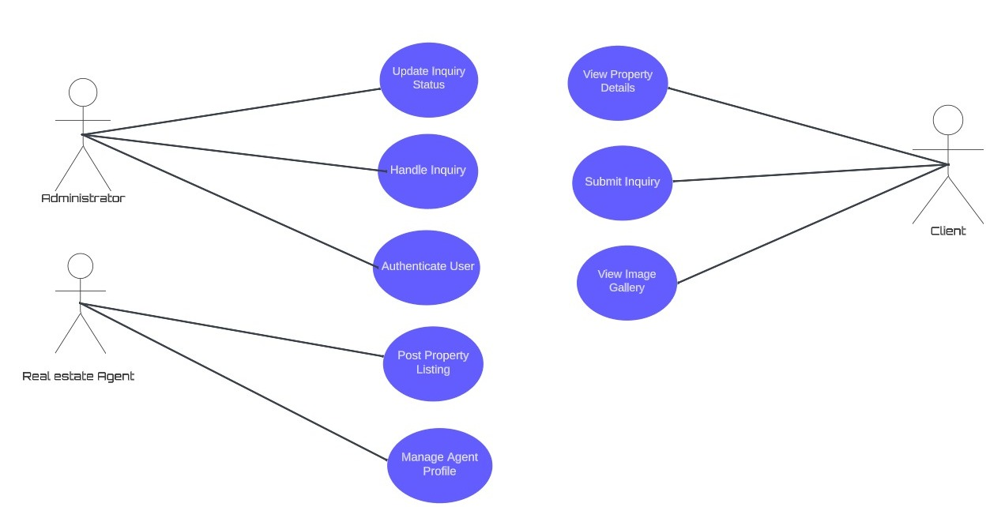

The Real Estate web site will serve two areas:

potential clients and realtors. It will utilize the scripting language PHP or JS and the relational database MySQL while being hosted on a web server. Since this system will be a web-based application/site, a proper Internet browser such as Firefox, Internet Explorer, etc. will be needed for viewing and interacting with its content

### 2.2 Product Function

Entity Relationship Diagram of Real Estate Listing

The agent/realtor and potential client must be able to utilize the Real Estate web site in the most efficient way possible with the given design and in regards with standardized web flow. The users need to be guided with easy to use web pages that are presented in a way that can accommodate even the novice user but all the while have the features that experienced users can take advantage of such as specific detailed searches. Each page will be neatly arranged and displayed in an easy to understand design

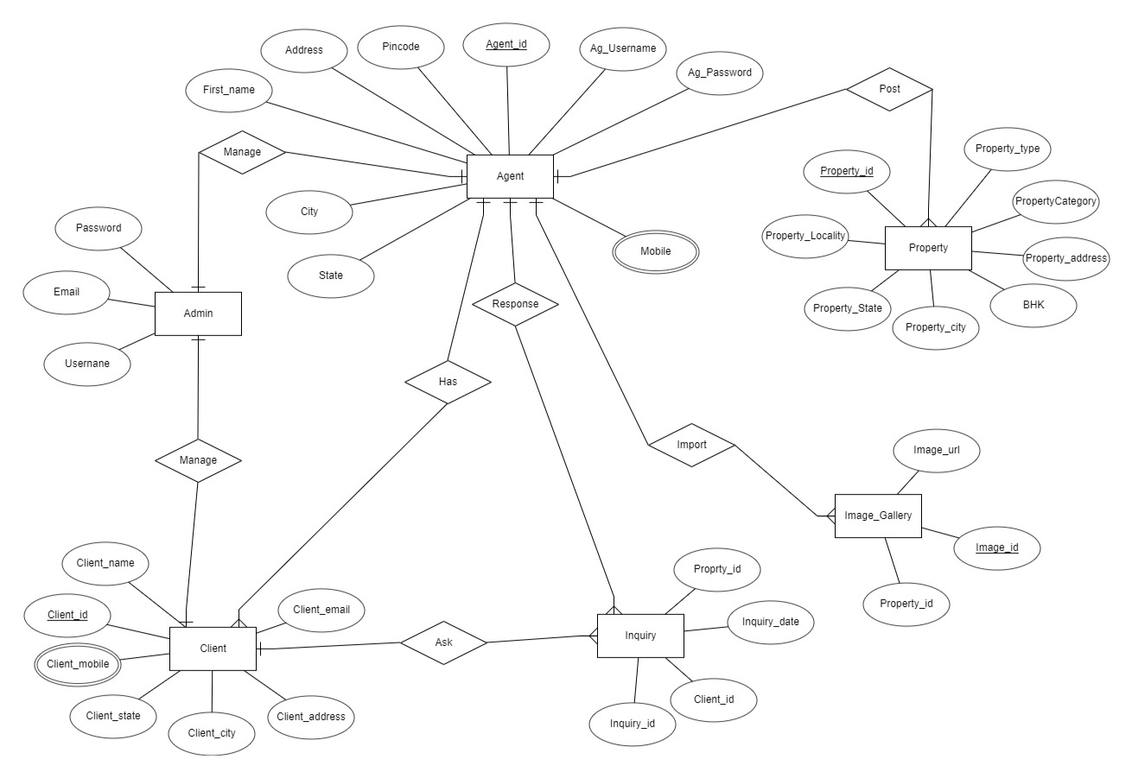

### 2.3 User Classes and Characteristics

The web site will include user interfaces both for the potential client and the owner/administrator for the site. There will be proper validation on each user interface page providing appropriate messages if any information is incorrectly entered. Each page of the web site will include a header and footer page to help keep the look and feel consistent throughout the web site.it contains:

* Homepage
* Search Listings:

The Search Listings page will allow the user to perform a detailed search of any available properties within the web site. Some of the search features will include listing type, bathrooms, bedrooms, price range, and location, among many others

* Agent Control Panel Login
* Register/Log in
* Contact Us:

The Contact Us page will provide the user the means to send an email to the web sites administrator.

* Agents Profile:

Profile page will display the realtors Name, Company Name, Description, Address, Phone Number, Fax, Mobile Phone,and AgentsListings. The user can send a message to that agent/realtor from this page too.

* Password reminder: The Password Reminder page will be linked out of the login page. It will allow the user to enter the E-Mail address they registered to use with the Real Estate website .The user will then receive an email containing their username and password they used during registration.
* Administrator (Realtor):
* Add Listing
* Listings Display

**2.4 Operating Environment**

The product will be operating in windows environment. The Real Estate Listings is a website and shall operate in all famous browsers, for a model we are taking Microsoft Internet Explorer, Google Chrome, and Mozilla Firefox. Also it will be compatible with the IE 6.0. Most of the features will be compatible with the Mozilla Firefox & Opera 7.0 or higher version. The only requirement to use this online product would be the internet connection.

The basic input devices required are keyboard, mouse and output devices are monitor, printer etc.

**2.5 Assumptions and Dependencies**

The assumptions are:-

* The coding should be error free
* The system should be user-friendly so that it is easy to use for the users
* The information of all clients, agents and property details must be stored in a database that is accessible by the website
* The system should have more storage capacity and provide fast access to the database
* The system should provide search facility and support quick transactions
* The Real Estate Listings System is running 24 hours a day
* Users may access from any computer that has Internet browsing capabilities and an Internet connection
* Users must have their correct usernames and passwords to enter into their online accounts and do actions

The dependencies are:-

The specific hardware and software due to which the product will be run

On the basis of listing requirements and specification the project will be developed and run

The end users (admin) should have proper understanding of the product

The system should have the general report stored

The information of all the users must be stored in a database that is accessible by the Listings System

Any update regarding the property from the agent/broker is to be recorded to the database and the data entered should be correct

**2.6 Requirement**

Software Configuration:-

This software package is developed using Javafx as front end which is supported by sun micro system. Microsoft SQL Server as the back end to store the database. Operating System: Windows NT, windows 98, Windows XP

Language: Java Runtime Environment, Javafx(front end)

Database: MS SQL Server (back end)

Hardware Configuration:-

Processor: Intel i5 12th gen

Hard Disk: 512 GB

RAM: 8 GB or more

### 2.7 Data Requirement

Input:

* User queries to the database, including actions like creating an account, selecting a property, and managing account information.

Output:

* + Database solutions corresponding to user queries.
  + User receives account details, presented in the form of time, date, and a list of currently associated properties.

This system enables users to seamlessly interact with the database, performing actions such as account creation, property selection, and account management. Upon user request, the server provides detailed account information, including relevant timestamps and a comprehensive list of currently held properties.

## 3. External Interface Requirement

### 3.1 GUI

The software provides good graphical interface for the user and the administrator can operate on the system, performing the required task such as create, update, viewing the details of the property.

* View concise reports such as Property Listings/Transactions within specific time frames.
* The system offers stock verification and a search feature based on various criteria for enhanced user convenience.
* Administrators have the flexibility to customize the user interface according to their preferences.
* All software modules seamlessly integrate into the graphical user interface, ensuring they meet defined standards.
* The design is user-friendly, with a simple layout, and all interfaces follow a consistent template.
* The user interface allows interaction with the user management module, with a dedicated section for the login/logout functionality.

Login Interface:-

In case the user is not yet registered, he can enter the details and register to create his account. Once his account is created he can ‘Login’ which asks the user to type his username and password. If the user entered either his username or password incorrectly then an error message appears.

Search:-

The client or agent can enter the type of property he is looking for and the details he is interested in, into the search bar and browse through the available properties that satisfies the given criteria.

Categories View:-

Categories view shows the categories of properties available and provides ability to the agent to add/edit or delete properties from a particular category list.

Agent’s Control Panel:-

This control panel will allow the property agent to add/remove available property; add, edit, or remove contact options and manage booking options.

## 4. System Features

The users of the system should be provided the surety that their account is secure. This is possible by providing:-

* User authentication and validation of client using their unique phone number.
* The administrator should maintain an accurate and up-to-date status for each property listing. This includes tracking the property’s availability, sale or rental status, and any other relevant information.
* Proper accountability which includes not allowing a user to see other user’s account. Only administrator will see and manage all member accounts

## 5. Other Non-functional Requirements

### 5.1 Performance Requirement

The proposed system that we are going to develop will be used as the Chief performance system within the different campuses of the university which interacts with the university staff and students. Therefore, it is expected that the database would perform functionally all the requirements that are specified by the university.



### 5.2 Safety Requirement

The database may get crashed at any certain time due to virus or operating system failure. Therefore, it is required to take the database backup so that the database is not lost. Proper UPS/inverter facility should be there in case of power supply failure.

### 5.3 Security Requirement

* System will use secured database
* Normal users can just read information but they cannot edit or modify anything except their personal and some other information.
* System will have different types of users and every user has access constraints
* Proper user authentication should be provided
* No one should be able to hack users’ password
* There should be separate accounts for admin and members such that no member can access the database and only admin has the rights to update the database.

### 5.4 Requirement attributes

* There may be multiple admins creating the project, all of them will have the right to create changes to the system. But the clients or agents or other users cannot do changes
* The project should be open source
* The Quality of the database is maintained in such a way so that it can be very user friendly to all the users of the database
* The user be able to easily download and install the system

### 5.5 Business Rules

A business rule is anything that captures and implements business policies and practices. A rule can enforce business policy, make a decision, or infer new data from existing data.This includes the rules and regulations that the System users should abide by. This includes the cost of the project and the discount offers provided. The users should avoid illegal rules and protocols. Neither admin nor member should cross the rules and regulations.

### 5.6 User Requirement

The users of the real estate system website are comprised of members seeking property information and real estate professionals who serve as administrators to oversee system maintenance. Members, presumed to possess basic computer and internet skills, utilize the platform for property exploration. On the other hand, administrators, equipped with a deeper understanding of the system's internals, handle potential issues arising from disk crashes, power failures, and other emergencies to ensure seamless system operation. The system is designed with an intuitive user interface, accompanied by a comprehensive user manual, online help resources, and installation/maintenance guides. These resources aim to empower both members and administrators with the knowledge necessary to navigate the system effortlessly and troubleshoot minor problems, thereby fostering a user-friendly and resilient real estate platform.

The admin provides certain facilities to the users in the form of:-

➢ Backup and Recovery

* Forgot Password
* Data migration i.e. whenever user registers for the first time then the data is stored in the server
* Data replication i.e. if the data is lost in one branch, it is still stored with the server
* Auto Recovery i.e. frequently auto saving the information
* Maintaining files i.e. File Organization
* The server must be maintained regularly and it has to be updated from time to time

## 6. Other Requirements

### 6.1 Data and Category Requirement

### In the real estate listings system, distinct user categories exist, including real estate agents, administrators, and clients. Access rights are contingent upon the user's category, with administrators possessing the authority to modify, delete, and append data. Conversely, users, excluding agents, have limited rights, primarily centered on retrieving information from the database. The system also incorporates diverse property categories, and data pertaining to each category is formatted and displayed accordingly. This ensures that users can efficiently access and explore relevant information aligned with specific property types within the real estate platform.

### Top of Form

### 6.2 Appendix

A: Admin, Abbreviation, Acronym, Assumptions, Agents; B: Business rules; C: Class, Client, Conventions; D: Data requirement, Dependencies; G: GUI; I:Inquiry, Image gallery; K: Key;

N: Non-functional Requirement; O:Operating environment; P:Performance,Perspective,Purpose,Property; R: Requirement, Requirement attributes; S: Safety, Scope, Security, System features; U: User, User class and characteristics, User requirement

### 6.3 Glossary

The following are the list of conventions and acronyms used in this document and the project as well:

* Administrator: A login id representing a user with user administration privileges to the software
* Agent: A general login id assigned to property sellers(mediums)
* Client: Property buyers
* Javafx: Creating GUI for java applications
* SQL: Structured Query Language; used to retrieve information from a database
* SQL Server: A server used to store data in an organized format
* Layer: Represents a section of the project
* User Interface Layer: The section of the assignment referring to what the user interacts with directly
* Application Logic Layer: The section of the assignment referring to the Web Server. This is where all computations are completed
* Data Storage Layer: The section of the assignment referring to where all data is recorded
* Use Case: A broad level diagram of the project showing a basic overview
* Class diagram: It is a type of static structure diagram that describes the structure of a system by showing the system’s cases, their attributes, and the relationships between the classes
* Interface: Something used to communicate across different mediums
* Unique Key: Used to differentiate entries in a database

### 6.4 Class Diagram

A class is an abstract, user-defined description of a type of data. It identifies the attributes of the data and the operations that can be performed on instances (i.e. objects) of the data. A class of data has a name, a set of attributes that describes its characteristics, and a set of operations that can be performed on the objects of that class. The classes’ structure and their relationships to each other frozen in time represent the static model. In this project there are certain main classes which are related to other classes required for their working. There are different kinds of relationships between the classes as shown in the diagram like normal association, aggregation, and generalization. The relationships are depicted using the role name and multiplicities. Here,’Agent’, ‘Client’ and ‘Admin’ are the most important classes which are related to other classes.

